Republic of the Philippines Bicol University



**POLANGUI CAMPUS**

Polangui, Albay [www.bupolangui.com](http://www.bupolangui.com/)

# SOFTWARE DESIGN

# Midterm Laboratory Exam

**ROSE ANN LISABA**

BSCPE-2A

**E-Commerce Website Project**

Website Name:

C++ (Coffee Plus Plus)

MODULE 1: USER ACCOUNT MANAGEMENT SYSTEM

This module would handle user registration, login, and profile management. Additionally, it may include features such as password reset, two-factor authentication, and user roles and permissions. The module would ensure secure storage of user data and provide a seamless user experience.

1. **FLOWCHART**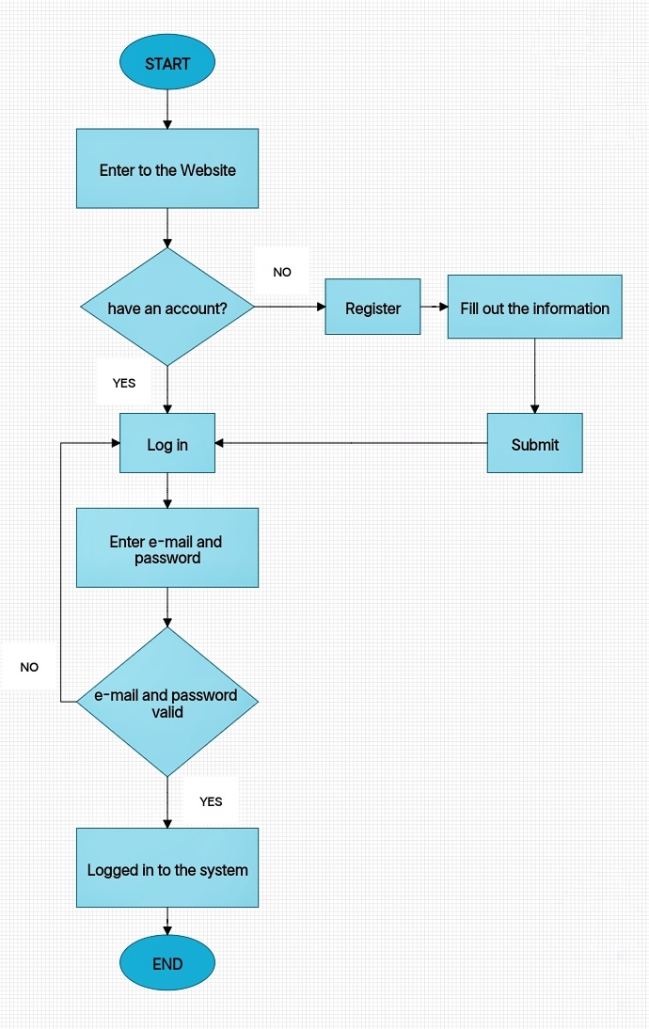

The flowchart depicts the process of a system for managing user accounts, which provides two options: Login and Registration. If the user selects Login, they must enter their email and password, and the system checks if the credentials are correct. If the email and password are valid, the user is logged in; otherwise, they are prompted to try again. If the user chooses Registration, they must provide details such as username, email address, and password, and the system submits this information to create a user account. The flowchart ends when the user logs out after completing their session.

1. **HIPO**

**HIERARCHY DIAGRAM**

Display user profile information

Update user profile information

Display order history

Collect registration information

Create a new account

Provide login credentials

Verify login credentials

Grant access to account

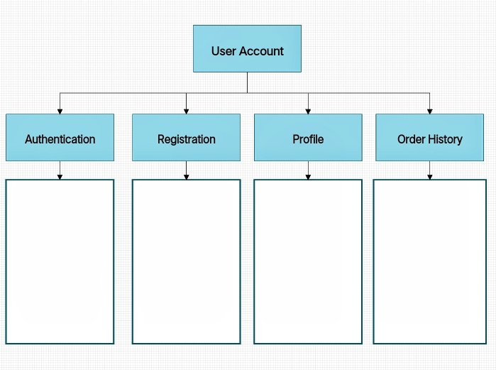

**INPUT – PROCESS – OUTPUT**

**OUTPUT**

- Authenticate user and grant access to account

- Create a new account and provide login credentials

- Display and update user profile information

- Display order history

**PROCESS**

- Authenticate user based on login credentials

- Create a new account based on registration information

- Manage user profile information

- Display order history

**INPUT**

- Login credentials (username and password)

- Registration information

- Profile information (name, email, etc.)

- Order history

The User Account system is composed of four main features: Authentication, Registration, Profile, and Order History. The system processes the user’s login credentials to grant access to their account, and allows for the creation of a new account by collecting registration information and providing login credentials. The system also manages user profile information by allowing for display and updates, and displays the user’s order history. Overall, the system takes in user information and processes it to provide access to an account, create new accounts, manage profile information, and display order history.

1. **DECISION TABLE**

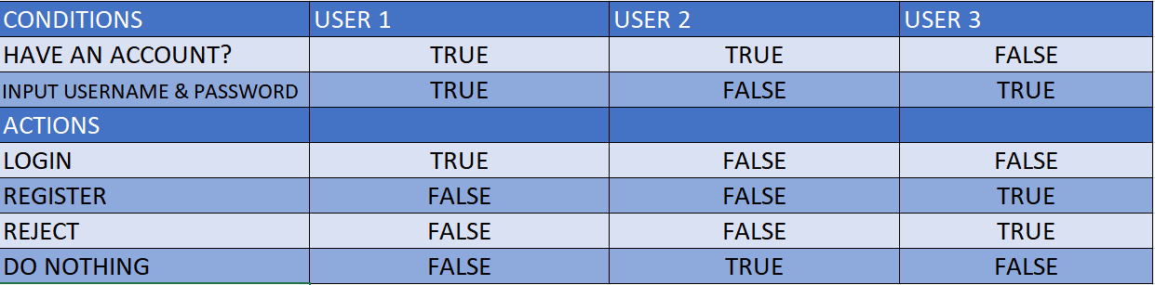In this decision table, the conditions are based on whether or not the user has an account, and if they have inputted their username and password. If the user has an account and inputs their username and password, the action taken is "Login". If the user does not have an account but inputs their username and password, the action taken is to "Register" a new account. If the user has an account but does not input their username and password, the action taken is to "Reject" the input. Lastly, if the user does not have an account and does not input their username and password, then no action is taken and the process is "Do Nothing". Essentially, this table outlines the different actions to be taken depending on the given conditions.

1. **DATA DICTIONARY**

This dataflow describes different fields and their associated types, lengths, constraints, and descriptions. The 'user_id' field is an integer with a length of 10, and it has the constraint of being the primary key and unique. The 'username' field is a varchar with a length of 50 and the constraint of not being null. The 'password' field is a varchar with a length of 50 also having the constraint of not being null. The 'age' field is an integer with length of 50, and the constraint of not being null. The 'firstname' field is a varchar with a length of 50 and the constraint of not being null. The 'surname' field is a varchar with length of 50 and the constraint of not being null. The 'address' field is a text with a length of 50 and the constraint of not being null. Finally, the 'contact' field is a varchar with a length of 50 and the constraint of not being null.

|  |  |  |  |  |
| --- | --- | --- | --- | --- |
| Field Name | Data Type | Length | Constraints | Description |
| user_id | Integer | 10 | Primary Key, Unique | Unique identifier for user |
| username | Varchar | 50 | Not null | Username of the user |
| password | Varchar | 50 | Not null | Password of the user |
| age | Integer | 50 | Not null | age Integer Age of the user |
| firstname | Varchar | 50 | Not null | First name of the user |
| surname | Varchar | 50 | Not null | Surname of the user |
| address | Text | 50 | Not null | Address of the user |
| contact | Varchar | 50 | Not null | Contact information of the user |

1. **DATA FLOW**

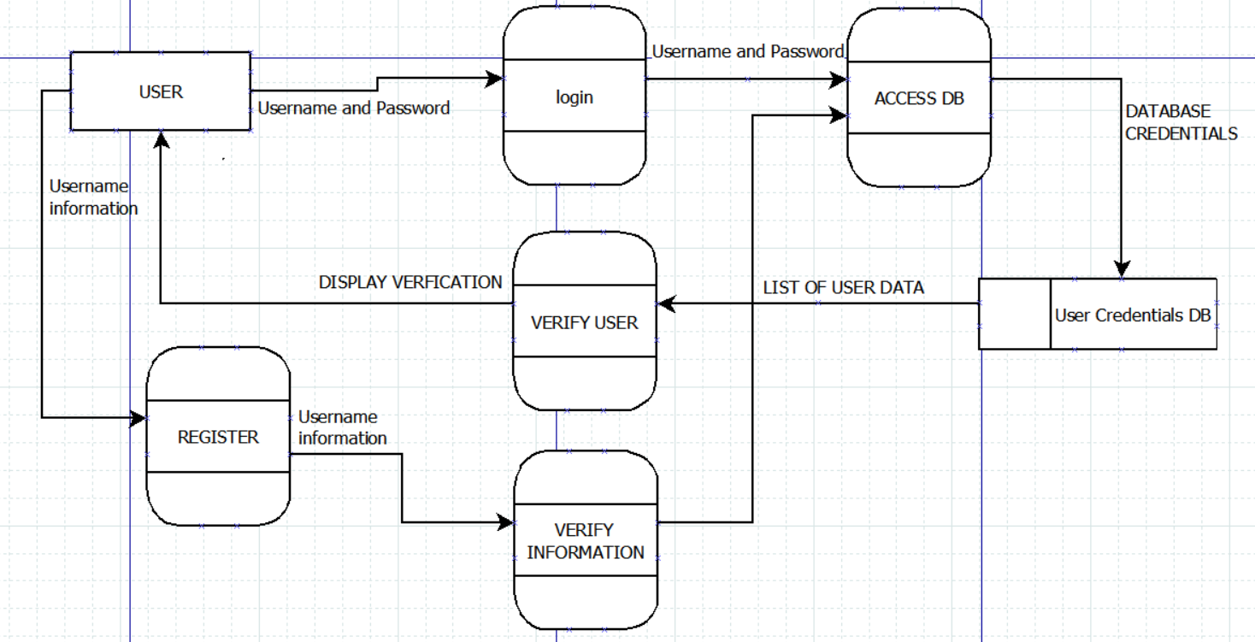The data flow for a login and register involves the user entering their credentials (username, password) into an authentication system. The system then checks if the credentials match any existing records in the database. If they do, the user is authenticated and can log in to the system. If not, the user can create an account by registering. The registration process includes collecting personal details such as name, address, email address, phone number, and other data. The authentication system then stores this information in the database to create a new user account.